

**MATHEMATICS:SPECIALIST 3 & 4**

**SEMESTER 1 2017**

**TEST 3**

**Resource Free**

Reading Time: 2 minutes

Time Allowed: 18 minutes Total Marks: 17

**1.** [3, 4 marks]

(a) Solve the system of equations

$x+y - z=4$

$x-y+3z=10$

$2x-y + z=11$

(b) State the number of solutions for each of the following systems of equations. In each case, interpret the system of equations geometrically.

(i) $2x+3y - z=5$

$3x-2y+4z=7$

$4x+6y-2z=8$

(ii) $2x+4y-6z=10$

$x+2y-3z=5$

$5x+3y+ z=7$

**2.** [2, 2 marks]

A sphere has centre $C(2, 5, -6)$. The points $A(-3, a, -3)$ and $B(b, 4, -9)$ form the diameter of the sphere.

(a) Determine the values of $a$ and $b$.

(b) Determine the vector equation of the sphere.

**3.** [2, 4 marks]

The points $P(3, 5, 2)$, $Q(6, 2, 5)$ and $R(2, 6, 3)$ all lie in the plane $Π$.

(a) Determine the vectors $PQ$ and $PR$.

(b) Determine the normal equation of the plane, $Π$, in the form $r∙n=c$.



**MATHEMATICS:SPECIALIST 3 & 4**

**SEMESTER 1 2017**

**TEST 3**

**Resource Assumed**

Reading Time: 2 minutes

Time Allowed: 33 minutes Total Marks: 32

**4.** [3, 3 marks]

A particle travels according to the equation $r=\left(1-2\cos{t}\right)i+3\sin{t}j$.

(a) State the Cartesian equation of the path of the particle.

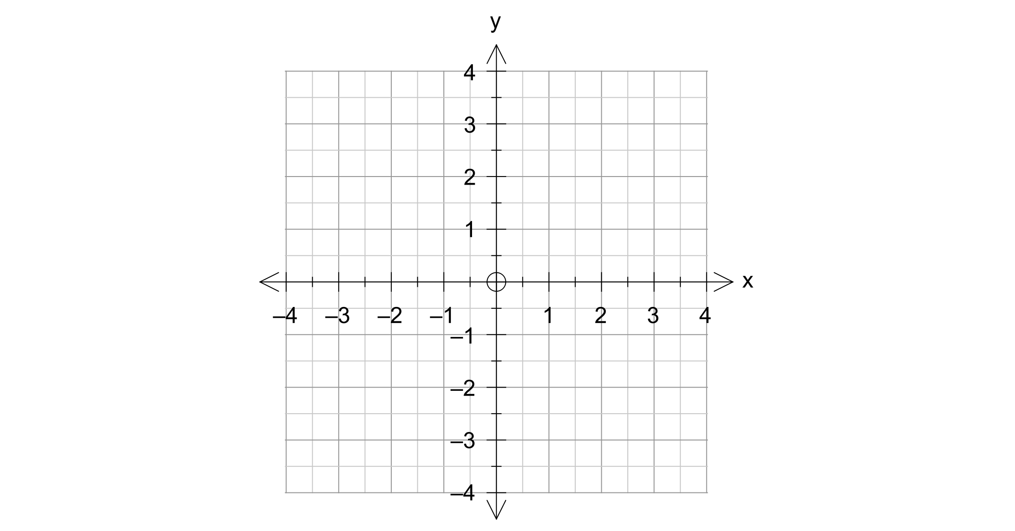

(b) Sketch the path of the particle for $0≤t≤5$ on the axes below.

**5.** [2, 3, 2, 2 marks]

The points $A(4, 1, 2)$, $B(1, 1, -3)$ and $C(-1, 5, 2)$ form a triangle.

(a) Determine vectors $AB$ and $AC$.

(b) Using the scalar product, determine the angle between vectors $AB$ and $AC$.

Give your answer in radians to two decimal places.

(c) Using your answer from (b), determine the area of the triangle $ABC$.

(d) Determine the exact value of $\frac{\left|\vec{AB}×\vec{AC}\right|}{2}$, and state the geometric significance of your answer.

**6.** [6, 4 marks]

A rocket is fired with velocity $\left(\begin{matrix}6.5 \\ 11 \\ 2.5\end{matrix}\right)$ km/min from a point with position vector $\left(\begin{matrix}-8 \\ 2 \\ 5\end{matrix}\right)$ km from some reference point $O$. At exactly the same time a second rocket is fired from the point $\left(\begin{matrix}24 \\ -10 \\ 7\end{matrix}\right)$ km with velocity $\left(\begin{matrix}-1.5 \\ 14 \\ 2\end{matrix}\right)$ km/min.

(a) Show that the rockets collide, and determine the time and position at which the collision takes place.

(b) If the second rocket had a velocity of $\left(\begin{matrix}-2 \\ 12 \\ 2\end{matrix}\right)$ km/min, determine the minimum distance that would occur between the two rockets. Give your answer to the nearest $10$ metres.

**7.** [1, 4, 2 marks]

A plane has Cartesian equation $3x-2y+4z=6$.

(a) Determine the normal equation for the plane.

(b) Determine the exact distance that the point $(8, -6, 7)$ is from the plane.

(c) Determine the Cartesian equation of a second plane that is parallel to the plane above, and contains the point $(8, -6, 7)$.